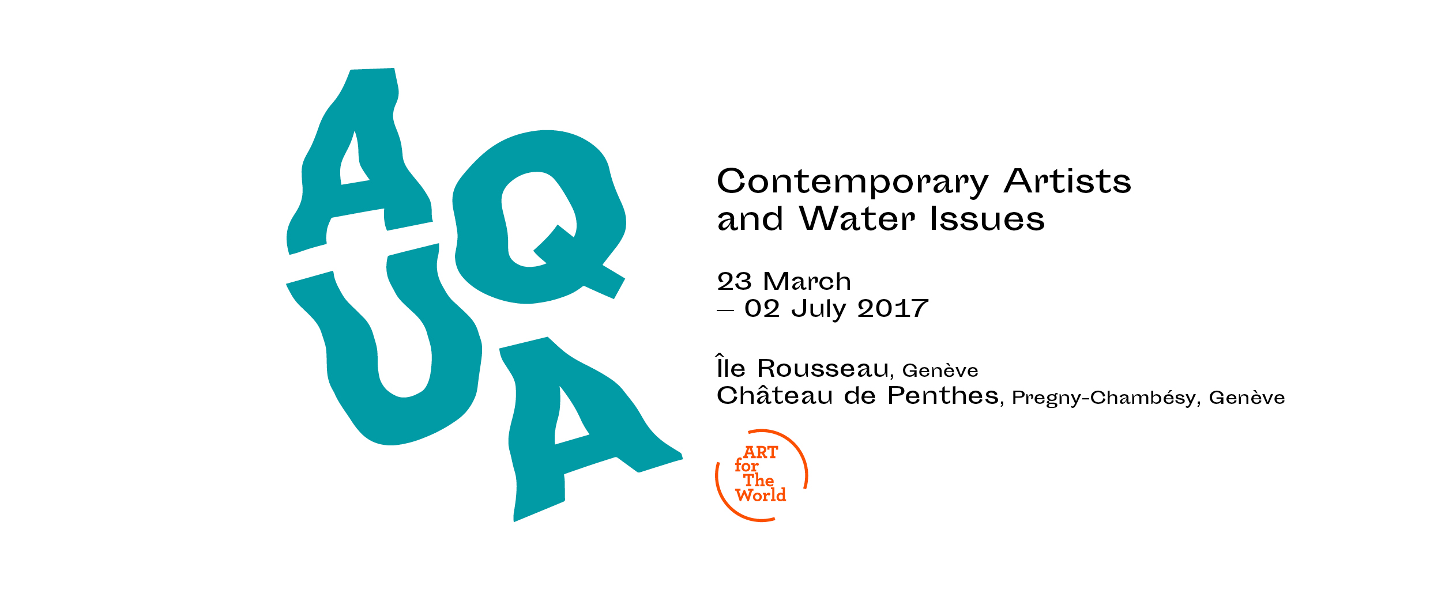
PRESS RELEASE

ART for The World presents AQUA, an international traveling exhibition inaugurated in Geneva on the 22 March 2017, World Water Day.
11:45 am – Meeting point at Île Rousseau for the beginning of the press visit.
12:15 am – Departure by chartered bus from Quai des Bergues to Château de Penthes for continuation of exhibition visit followed by the press conference and a buffet.

Continuing its mission to raise awareness on essential issues of our times through contemporary art, the new art project of ART for The World, is AQUA, an international travelling exhibition focusing on water and its importance to human beings, fauna and flora, curated by Adelina von Fürstenberg.
AQUA aims to emphasize our collective responsibility on the role and use of water in our world today, where water management is a major challenge and a priority objective of the 21st century.
The exhibition is presented in avant-première from Geneva, a quintessential city of water, where the Rhône River, after running through the Canton of Valais and forming Lake Leman, flows through the heart of Geneva where it converges with the Arve River before continuing on to Lyon and the Mediterranean Sea.

Most being presented for the first time, the artworks by 30 contemporary artists from differing horizons, touch on the preservation of water. The exhibition is conceived to raise public awareness of the notion of interdependence, essential to the conservation of our environment and to the future of our planet. When water is under menace, so too are all forms of life on Earth. Recognised as a vital life-giving element, water is essential to preserving biodiversity and ecosystems. As a human resource, it is at the centre of climate change and its consequences, a possible origin, or a subject of conflict.
Invited artists and filmmakers:
Omar Ba, Nigol Bezjian, Clemente Bicocchi, Stefano Boccalini, Alighiero Boetti, Benji Boyadgian, Jonathas de Andrade, Silvie Defraoui, Michel Favre, Noritoshi Hirakawa, Francesco Jodice, Ilya and Emilia Kabakov, Shin Il Kim, Alexander Kosolapov, Salomé Lamas, Marcello Maloberti, Andrea Marescalchi, Marcelo Moscheta, Stéphanie Nava, Luca Pancrazzi, Dan Perjovschi, George Pusenkoff, Shimabuku, Eduardo Srur, Barthélémy Toguo, Maria Tsagkari, Velu Viswanadhan, Gal Weinstein, Vasilis Zografos.

AQUA is presented on World Water Day, 22 March 2017, granting the artists expression, on this symbolic occasion, of their engagement to this indispensable element on which we all rely.

The exhibition will take place in two different locations in Geneva:
From 23 March to 31 May at Île Rousseau, Quai des Bergues, located on the Rhône River in the heart of the city.
From 23 March to 2 July at Château de Penthes in Pregny-Chambésy, located in the area of the United Nations and international organizations.
AQUA after Geneva will be presented in a newest version at SESC Belenzhino, São Paulo, Brazil, from November 2017 to February 2018, and continue his itinerary in 2018, on other continents.
Catalogue
The exhibition is accompanied by a colour catalogue of 120 pages with the contributions of the artists, art critics, and specialist from various fields offering a multi-faceted approach to the issues of water.
Support and Partnerships
In the framework of building awareness for the Sustainable Development Goals of the UN, AQUA is organized with the support of the DDC/DFAE (Swiss Agency for Development and Cooperation / Federal Department of Foreign Affairs), Department of Culture and Sport of the City of Geneva, FMAC (City of Geneva Contemporary Art Fund), Loterie Romande, Pour-cent culturel Migros, HelvéCie S.A., Eeckman Art & Insurance, among others;
and in partnership with UN Water, Foundation for Geneva, and the Geneva Water Hub.
CBH (Swiss Banking Company) is the Global Partner 2016-2017 of ART for the World.
Special Thanks
Guillaume Barazzone, Administrative Councillor, Mayor of Geneva; Sami Kanaan, Administrative Councillor in charge of the Department of Culture and Sport of the City of Geneva ; Michel Jarraud, Honorary Secretary-General of the World Meteorological Organization (WMO), Geneva; International Geneva Bureau, Republic and State of Geneva; Aqua Viva, Gewässerschutzorganisation, Switzerland; Agata Boetti, Paris; Anahelena Curti, Arte3 / São Paulo; Jack Persekian, Jerusalem; Julie and Edoardo Bugnone, Geneva; Nadine Tarbouriech, Paris; Serena Bencini and Archivio Marescalchi, Florence; Thomas Schumann, Water Security Fund, Santa Monica / LA; Frac Provence-Alpes-Côte d’Azur; Bandjoun Station, Cameroon; and the galleries of Riccardo Crespi, Milan; Air de Paris, Paris; Anadiel, Jerusalem; Guy Bärtschi, Geneva; Sébastien Bertrand, Geneva; Blondeau & Cie, Geneva, Andrea Caratsch, St. Moritz; Lelong, Paris; Sprovieri, London; and Vermelho, São Paulo.
ART for The World
An NGO (Non-Governmental Organisation) and a Public Utility of the Canton of Geneva affiliated with the UNDPI (United Nations Department of Public Information), ART for The World mobilizes art, cinema and contemporary culture addressing compelling issues in our society. Since its founding in 1996, ART for The World has conceived numerous traveling exhibitions and produced several short movies. Since 1998, ART for The World regularly collaborates with the Regional Direction of the SESC São Paulo in Brazil. In 2005, its sister organization, ART for The World Europa was founded in Italy.

Press Information
ART for The World Château de Penthes
Nunu Luan and Alexis Kasparians Camille Verdier
7 rue Monnier 18 Chemin de l'Impératrice
1206 Geneva 1292 Pregny-Chambésy, Geneva
+ 41 22 789 1557 +41 22 827 36 17
projects@artfortheworld.net verdier@penthes.ch
www.artfortheworld.net www.penthes.ch
www.aqua-artfortheworld.net

